ONLINE BOOK SHOP

Submitted by,
Jasna M Pareeth
Roll no: 29
MCA LE S3

TABLE DESIGN

Table no: 1
Table: tbl_Login
Primary Key : login_id
Table Description: To store All user Login Details

Field name | Data type | Description
login_id | Int | Login id
user_name | Varchar(30) | User name
password | Varchar(30) | Password
status | Int | Status

Table no: 2
Table: tbl_regestration
Primary Key : user_id
Table Description: To store All user registration Details

Field name | Data type | Description
User_id | int | User id
name | Varchar(30) | User name
Login_id | int | Login id
address | Varchar(50) | Address
District_id | Int | District Name
City_name | Varchar(30) | City Name
Pincode | Int | Pin code
Contact_number | Int | Contact number
Seq_question | Varchar(30) | Security question
Seq_answer | Varchar(30) | Security answer

Table no: 3
Table: tbl_state
Primary Key : state_id
Table Description: To store stateDetails

Field name | Data type | Description
State_id | Int | State id
State_name | Varchar(30) | State name

Table no: 4
Table: tbl_district
Primary Key : district_id
Table Description: To store districtDetails

Field name | Data type | Description
District_id | Int | District id
State_id | int | State id
District_name | Varchar(30) | District name

Table no: 5
Table: tbl_category
Primary Key : cat_id
Table Description: To store all category Details

Field name | Data type | Description
cat_id | Int | Category id
cat_name | Varchar(30) | Category name

Table no: 6
Table: tbl_subcategory
Primary Key : subcat_id
Table Description: To store All sub category Details

Field name | Data type | Description
Subcat_id | Int | Sub category id
Subcat_name | Varchar(30) | Sub category name
cat_id | int | Category id

Table no: 7
Table: tbl_image
Primary Key : img_id
Table Description: To store the images and pdf of each book

Field name | Data type | Description
img_id | int | Image Id
img_name | Varchar(20) | Image Name
book_id | int | Book id

Table no: 8
Table: tbl_book
Primary Key : book_id
Table Description: To store All book Details

Field name | Data type | Description
book_id | int | Book id
title | Varchar(30) | Book name
subcatat_id | Int | Sub category id
description | Varchar(30) | Description of book
author | Varchar(30) | Author name
author_desc | Varchar(30) | About author
otherbooks | Varchar(30) | Other books of author
publisher | Varchar(30) | Publisher
yopublisher | Int | Year of publishing
language | Varchar(30) | Language
qnty | Int | Quantity
price | Int | Price
discnt_price | Int | Discount price
f_img | Varchar(30) | Cover page of book
b_img | Varchar(30) | Back cover image
pageno | Int | Page number of the book
binding | Varchar(30) | Type of binding
edition | Varchar(30) | Edition of the book

Table no: 9
Table: tbl_order
Primary Key : order_id
Table Description: To store order Details

Field name | Data type | Description
order_id | Int | Order id
user_id | Int | User name
book_id | Int | Book name
date | Date | Date of order
qty | Int | Quantity
status | Int | Status

Table no: 10
Table: tbl_payement
Primary Key : p_id
Table Description: To store payement details

Field name | Data type | Description
p_id | Int | Payement id
user_id | Int | User id
p_type | Int | Payement type
card_type | Varchar(30) | Card type
card_no | Int | Card number
card_hname | Varchar(30) | Card holder name
expiry | Date | Expiry date of card
cvd | Int | Cvd code

Table no: 11
Table: tbl_cart
Primary Key : cart_id
Table Description: To store the cart details of each users

Field name | Data type | Description
cart_id | Int | Cart id
book_id | Int | Book id
user_id | int | User id
qnty | Int | Quantity

Table no: 12
Table: tbl_wishlist
Primary Key : id
Table Description: To store All users wishlist Details

Field name | Data type | Description
id | Int | Id
user_id | Int | User id
book_name | Varchar(30) | Which book the user wants
description | Varchar(30) | Description

Table no: 13
Table: tbl_rating
Primary Key : rating_id
Table Description: To store All user rating Details

Field name | Data type | Description
rating_id | Int | Rating id
book_id | Int | Book id
user_id | Int | User id
rating | int | Rating number

Table no: 14
Table: tbl_author
Primary Key : author_id
Table Description: To store All author Details

Field name | Data type | Description
author_id | int | Author id
author_name | Varchar(30) | Author name
books | Varchar(30) | Book names

FORM DESIGN

- LOGIN FORM:-

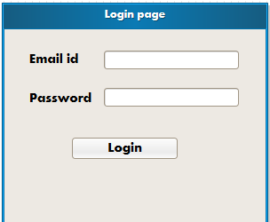

- REGESTRATION FORM

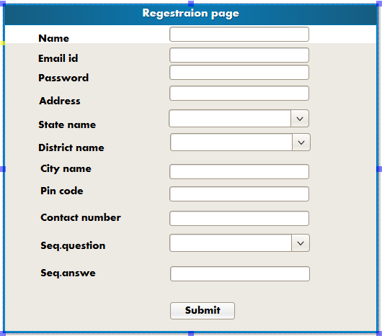

- BOOK DETAILS

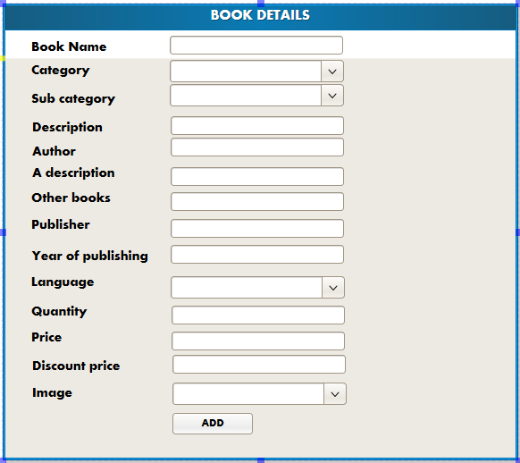
- SUBCATEGORY FORM

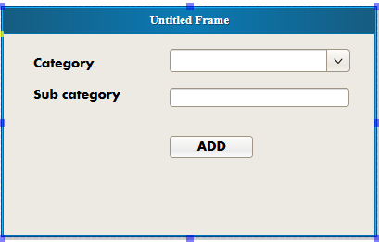

- CATEGORY FORM

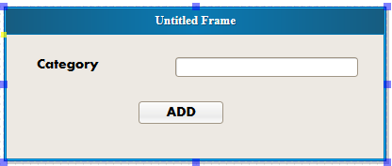

- IMAGE INSERTION FORM

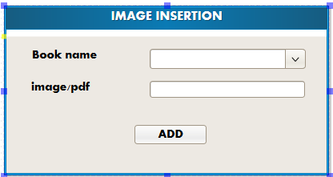

- PAYEMENT DETAILS:-

